PROJECT DEVELOPMENT PHASE

DELIVERY OF SPRINT-3

|  |  |
| --- | --- |
| Date | 12 November 2022 |
| Team Id | PNT2022TMID08806 |
| Project Name | Hazardous area monitoring for industrial power plants using IOT. |

SPRINT 3: MIT Application Inventor

* Building an application for our project using MIT application, designing the model and testing the application.

STEP 1: Connecting required nodes in the Node-red platform.

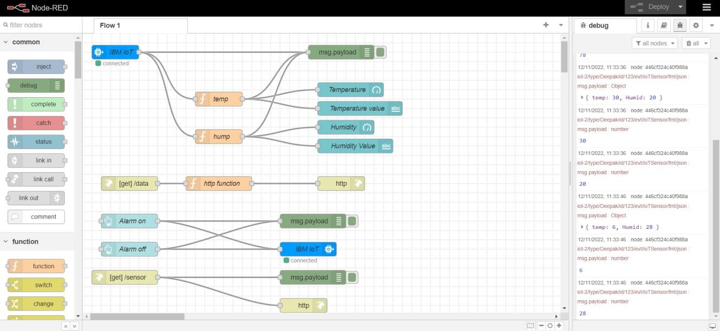

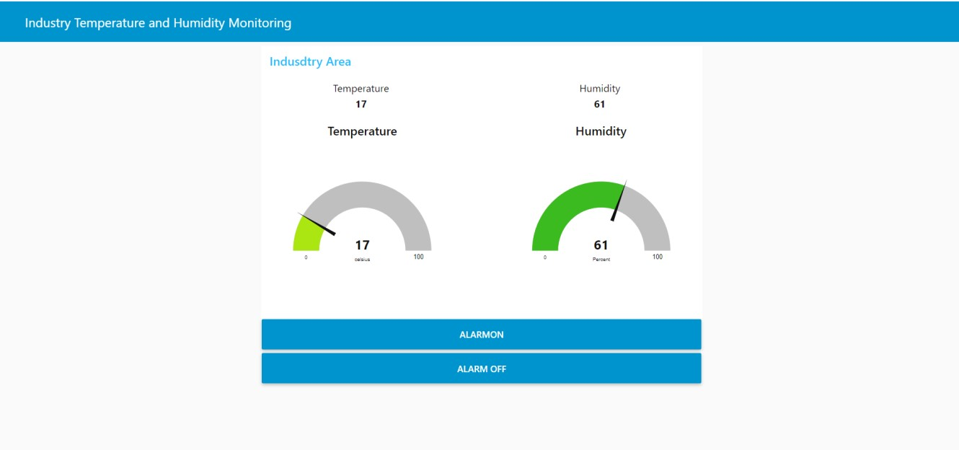

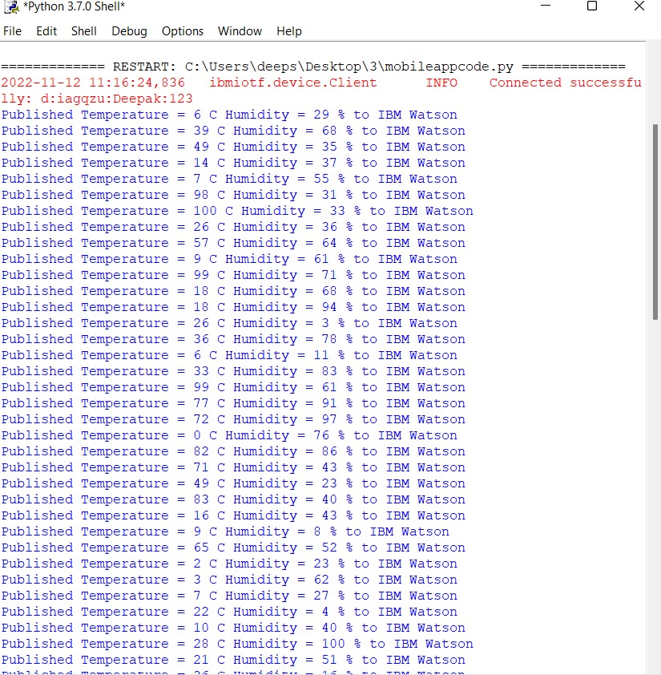

STEP 2: Displaying Alarm condition [https://node-red-cgxsy-2022-10-06.eugb.mybluemix.net/control?command=AlarmOn](https://node-red-cgxsy-2022-10-06.eu-gb.mybluemix.net/control?command=AlarmOn)

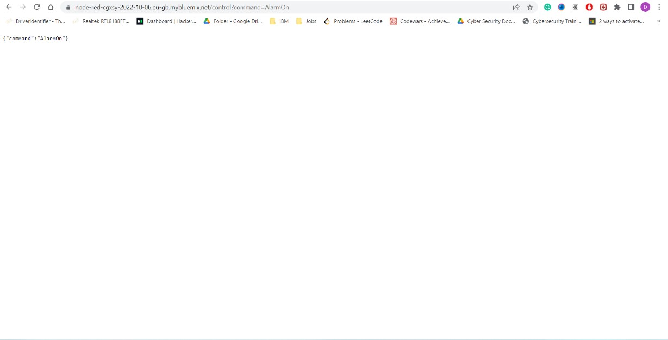

STEP 3: Connecting with the MIT Application Inventor to display temperature,

humidity and alarm condition.

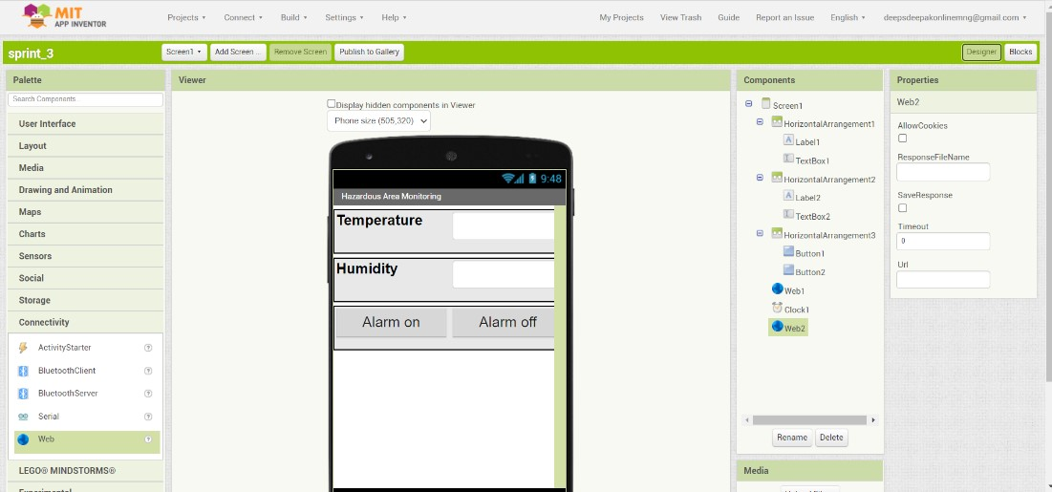

STEP-4: Attaching web link with the connected blocks in the MIT application inventor

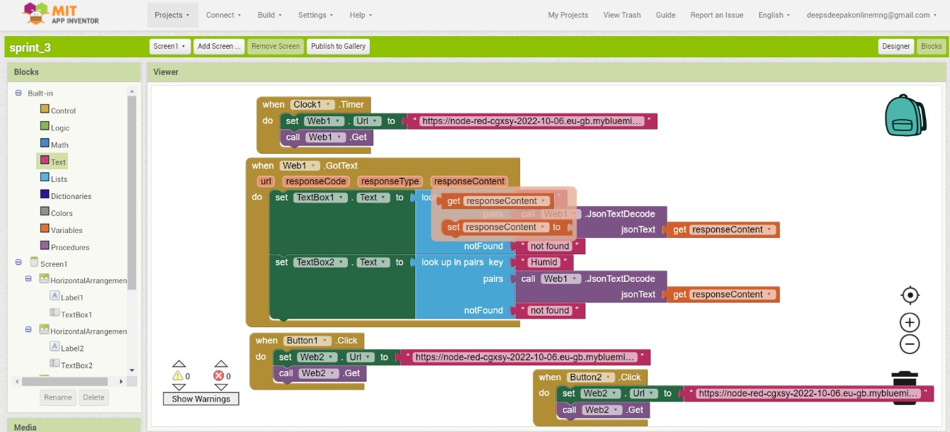

STEP-5: Detecting high temperature and displaying “ALERT” message in the MIT application.

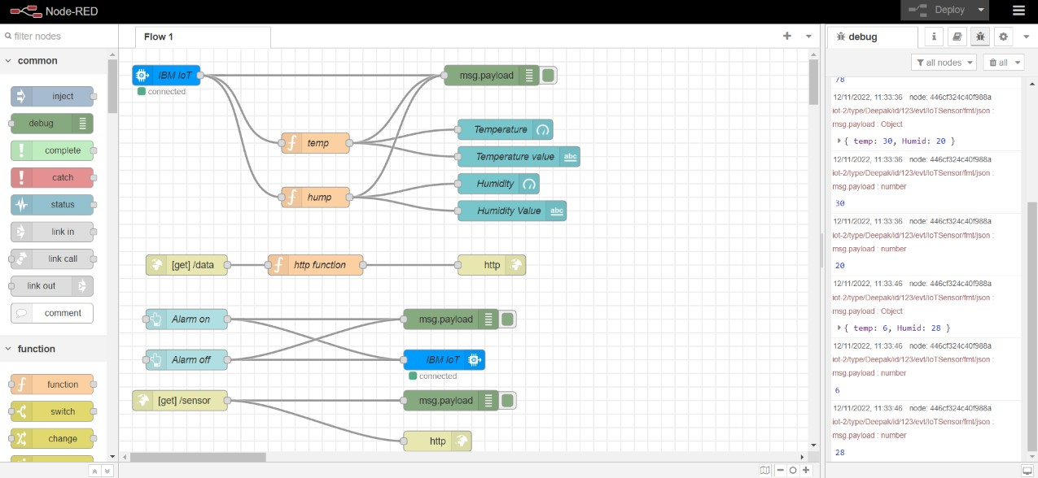

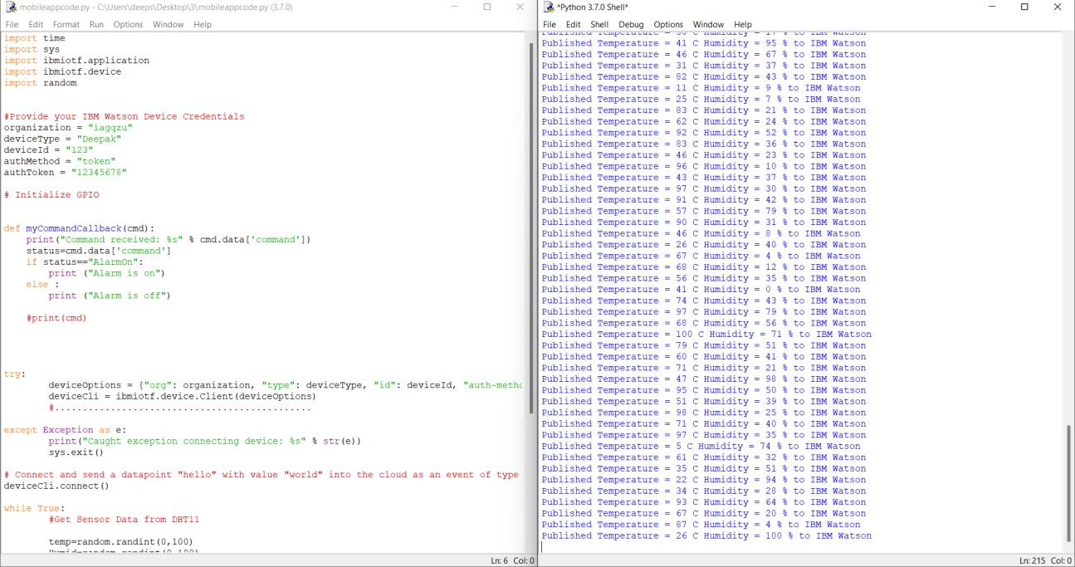

STEP 6: Downloading apk file and building mobile application using python script for sensing temperature for hazardous area monitoring conditions in industrial areas.

